Python Flask Tutorial
Last Updated : 25 May 2026

Flask Tutorial provides the basic and advanced concepts of the Python Flask framework. Our Flask tutorial is designed for beginners and professionals.
Flask is a web framework that provides libraries to build lightweight web applications in python. It is developed by Armin Ronacher who leads an international group of python enthusiasts (POCCO).
What is Flask?
Flask is a web framework that provides libraries to build lightweight web applications in python. It is developed by Armin Ronacher who leads an international group of python enthusiasts (POCCO). It is based on WSGI toolkit and jinja2 template engine. Flask is considered as a micro framework.
What is WSGI?
It is an acronym for web server gateway interface which is a standard for python web application development. It is considered as the specification for the universal interface between the web server and web application.
What is Jinja2?
Jinja2 is a web template engine which combines a template with a certain data source to render the dynamic web pages.
Flask Environment Setup
To install flask on the system, we need to have python 2.7 or higher installed on our system. However, we suggest using python 3 for the development in the flask.
Install virtual environment (virtualenv)
virtualenv is considered as the virtual python environment builder which is used to create the multiple python virtual environment side by side. It can be installed by using the following command.
- $ pip install virtualenv
Once it is installed, we can create the new virtual environment into a folder as given below.
- $ mkdir new
- $ cd new
- $ virtualenv venv
To activate the corresponding environment, use the following command on the Linux operating system.
- $ venv/bin/activate
On windows, use the following command.
- $ venv\scripts\activate
We can now install the flask by using the following command.
- $ pip install flask
However, we can install the flask using the above command without creating the virtual environment.
To test the flask installation, open python on the command line and type python to open the python shell. Try to import the package flask.
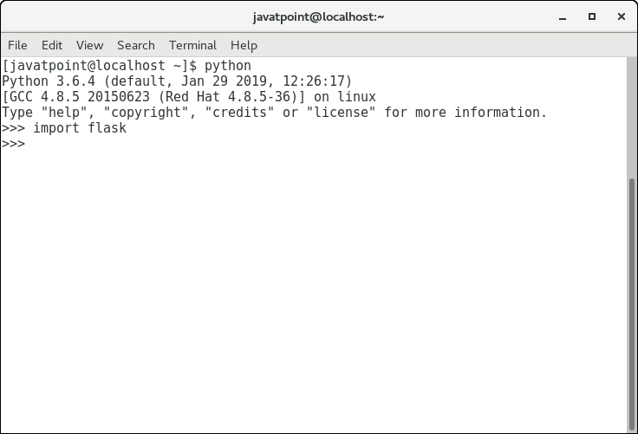
We have successfully installed the flask since we do not get the error in the process. Now, we can continue with the tutorial.
Prerequisite to Learn Flask
Before learning Flask, you should have a basic understanding of Python programming concepts such as variables, functions, loops, classes, and modules. Basic knowledge of HTML and web development concepts will also help you understand Flask applications more easily.
Audience to Learn Flask
This Flask tutorial is designed for students, beginners, web developers, and professionals who want to learn Flask for web application development. It is suitable for both beginners and experienced programmers who want to build web applications using Python and Flask.
Problem
We assure you that you will not find any problem in this Python Flask tutorial. But if there is any mistake, please post the problem in the contact form.
Career Opportunities After Learning Flask
Learning Flask can help you build a career in Python web development and backend application development. Flask is widely used for developing web applications, REST APIs, microservices, and dynamic websites.
After learning Flask, you can apply for roles such as:
- Python Developer
- Flask Developer
- Backend Developer
- Web Application Developer
- API Developer
- Full Stack Developer
- Software Engineer
Flask knowledge is also useful for developers working with cloud platforms, database systems, automation tools, and modern web technologies.
First Flask Application
Last Updated : 25 May 2026
In this chapter, we will create our first web application using the Flask framework. Flask is a lightweight Python web framework used for building web applications and APIs.
To create the Flask application, you can use any text editor such as Sublime Text, VS Code, or PyCharm. Here, we are using Sublime Text Editor.
Creating Your First Flask Program
Create a Python file named script.py and write the following code.

- from flask import Flask
- app = Flask(__name__) #creating the Flask class object
- @app.route('/') #decorator defines the
- def home():
- return "hello, this is our first flask website";
- if __name__ =='__main__':
- app.run(debug = True)
Running the Flask Application
After writing the code, save the file and run it using the command line.
python script.py
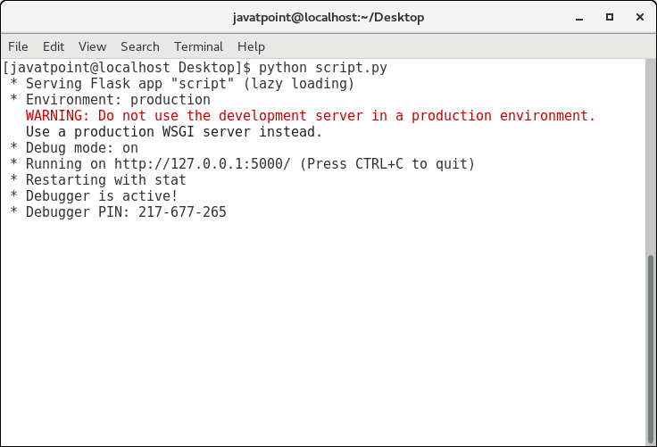
When the program runs successfully, Flask starts a local development server.
Viewing the Output in Browser
Since Flask creates a web application, the output is viewed in a web browser.
Open the following URL in your browser:
http://localhost:5000
When you open the URL, the browser will display:
hello, this is our first flask website
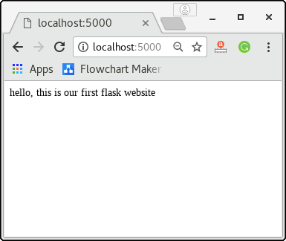
Understanding the Flask Code
Let us understand each part of the Flask application.
Importing the Flask Module
The following statement imports the Flask class from the Flask package.
- from flask import Flask
This module provides all the required functions and classes for creating Flask web applications.
Creating Flask Application Object
The following line creates an object of the Flask class.
- app = Flask(__name__)
This object acts as the WSGI application for handling requests and responses.
Here, __name__ represents the name of the current Python module.
Using the route() Decorator
The route() function is used to map a URL with a Python function.
- @app.route('/')
In this example, the / URL is connected with the home() function.
Whenever a user opens the home URL, Flask executes the associated function automatically.
Creating the Home Function
The following function returns the response displayed in the browser.
- def home():
- return "hello, this is our first flask website"
A Flask function can return:
- Plain text
- HTML content
- HTML templates
- JSON data
Running the Flask Application Server
The run() method starts the Flask development server.
- app.run(debug=True)
The debug=True option enables debug mode and displays error details during development.
Syntax of route() Method
The syntax of the route() method is:
- app.route(rule, options)
Parameters of route() Method
The following parameters are used in the route() method.
- rule: It represents the URL pattern associated with the function.
- options: It represents additional parameters associated with the route object.
Syntax of run() Method
The syntax is given below.
- app.run(host, port, debug, options)
In the given syntax,
SN | Option | Description
1 | Host 127.0.0.1 | The default hostname is 127.0.0.1, i.e. localhost.
2 | Port5000 | The port number to which the server is listening to. The default port number is 5000.
3 | Debug | The default is false. It provides debug information if it is set to true.
4 | Options | It contains the information to be forwarded to the server.
Flask App routing
Last Updated : 25 May 2026
App routing is used to map the specific URL with the associated function that is intended to perform some task. It is used to access some particular page like Flask Tutorial in the web application.
In our first application, the URL ('/') is associated with the home function that returns a particular string displayed on the web page.
In other words, we can say that if we visit the particular URL mapped to some particular function, the output of that function is rendered on the browser's screen.
Consider the following example.
Example: Basic Flask App Routing
This example demonstrates how to map a URL with a function using the route() decorator in Flask.
- from flask import Flask
- app = Flask(__name__)

- @app.route('/home')
- def home():
- return "hello, welcome to our website";

- if __name__ =="__main__":
- app.run(debug = True)
Flask facilitates us to add the variable part to the URL by using thesection. We can reuse the variable by adding that as a parameter into the view function. Consider the following example.
Example: App Routing with Variable URL
This example demonstrates how to pass variables through the URL and use them inside the Flask view function.

- from flask import Flask
- app = Flask(__name__)
- @app.route('/home/<name>')
- def home(name):
- return "hello,"+name;
- if __name__ =="__main__":
- app.run(debug = True)
It will produce the following result on the web browser.
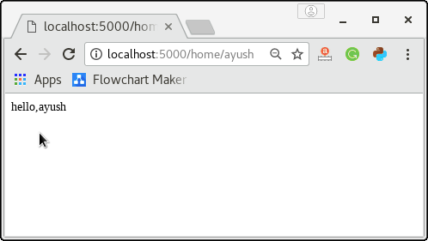
The converter can also be used in the URL to map the specified variable to the particular data type. For example, we can provide the integers or float like age or salary respectively.
Consider the following example.
Example: App Routing with Integer Converter
This example demonstrates how to use data type converters such as int in Flask URL routing.
- from flask import Flask
- app = Flask(__name__)

- @app.route('/home/<int:age>')
- def home(age):
- return "Age = %d"%age;

- if __name__ =="__main__":
- app.run(debug = True)
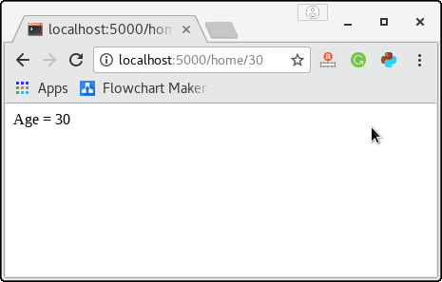
The following converters are used to convert the default string type to the associated data type.
- string: default
- int: used to convert the string to the integer
- float: used to convert the string to the float.
- path: It can accept the slashes given in the URL.
The add_url_rule() function
There is one more approach to perform routing for the flask web application that can be done by using the add_url() function of the Flask class. The syntax to use this function is given below.
- add_url_rule(<url rule>, <endpoint>, <view function>)
This function is mainly used in the case if the view function is not given and we need to connect a view function to an endpoint externally by using this function.
Consider the following example.
Example: Using add_url_rule() Function
This example demonstrates how to perform routing in Flask using the add_url_rule() function instead of the route() decorator.
- from flask import Flask
- app = Flask(__name__)

- def about():
- return "This is about page";

- app.add_url_rule("/about","about",about)

- if __name__ =="__main__":
- app.run(debug = True)
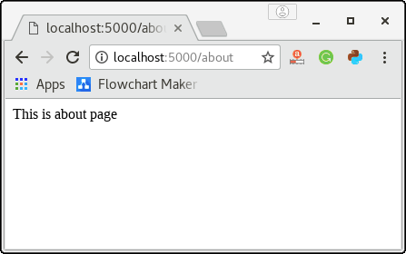

Flask URL Building
The url_for() function in Flask is used to dynamically create URLs for specific functions. It helps avoid hard-coded URLs in Flask applications and makes URL management easier and more flexible.
The first argument of the url_for() function is the function name, and additional keyword arguments can be passed for variable parts of the URL.
Example: Building URL Using url_for()
This example demonstrates how to dynamically generate URLs in a Flask application using the url_for() function.
- from flask import *

- app = Flask(__name__)

- @app.route('/admin')
- def admin():
- return 'admin'

- @app.route('/librarion')
- def librarion():
- return 'librarion'

- @app.route('/student')
- def student():
- return 'student'

- @app.route('/user/<name>')
- def user(name):
- if name == 'admin':
- return redirect(url_for('admin'))
- if name == 'librarion':
- return redirect(url_for('librarion'))
- if name == 'student':
- return redirect(url_for('student'))
- if __name__ =='__main__':
- app.run(debug = True)
The above script simulates the library management system which can be used by the three types of users, i.e., admin, librarion, and student. There is a specific function named user() which recognizes the user the redirect the user to the exact function which contains the implementation for this particular function.
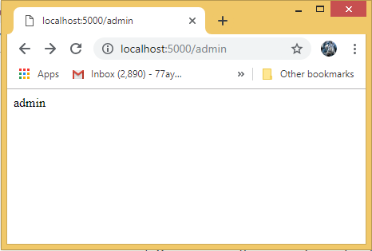
For example, the URL http://localhost:5000/user/admin is redirected to the URL http://localhost:5000/admin, the URL localhost:5000/user/librarion, is redirected to the URL http://localhost:5000/librarion, the URL http://localhost:5000/user/student is redirected to the URL http://localhost/student.
Benefits of the Dynamic URL Building
- It avoids hard coding of the URLs.
- We can change the URLs dynamically instead of remembering the manually changed hard-coded URLs.
- URL building handles the escaping of special characters and Unicode data transparently.
- The generated paths are always absolute, avoiding unexpected behavior of relative paths in browsers.
- If your application is placed outside the URL root, for example, in /myapplication instead of /, url_for() properly handles that for you.

Flask HTTP methods
HTTP (HyperText Transfer Protocol) is the foundation of data communication on the World Wide Web. Flask supports different HTTP methods that are used for sending and receiving data between the client and the server.
These HTTP methods help web applications perform operations such as requesting data, submitting forms, updating information, and deleting records.
Flask HTTP Methods
The commonly used HTTP methods are given in the following table.
SN | Method | Description
1 | GETCREATE | It is the most common method which can be used to send data in the unencrypted form to the server.
2 | HEAD | It is similar to the GET but used without the response body.
3 | POSTREAD | It is used to send the form data to the server. The server does not cache the data transmitted using the post method.
4 | PUT-- UPDATE | It is used to replace all the current representation of the target resource with the uploaded content.
5 | DELETEDELETE | It is used to delete all the current representation of the target resource specified in the URL.
We can specify which HTTP method to be used to handle the requests in the route() function of the Flask class. By default, the requests are handled by the GET() method.
POST Method
To handle the POST requests at the server, let us first create a form to get some data at the client side from the user, and we will try to access this data on the server by using the POST request.

login.html
- <html>
- <body>
- <form action = "http://localhost:5000/login" method = "post">
- <table>
- <tr><td>Name</td>
- <td><input type ="text" name ="uname"></td></tr>
- <tr><td>Password</td>
- <td><input type ="password" name ="pass"></td></tr>
- <tr><td><input type = "submit"></td></tr>
- </table>
- </form>
- </body>
- </html>
Now, Enter the following code into the script named post_example.py.
post_example.py
- from flask import *
- app = Flask(__name__)
- @app.route('/login',methods = ['POST'])
- def login():
- uname=request.form['uname']
- passwrd=request.form['pass']
- if uname=="ayush" and passwrd=="google":
- return "Welcome %s" %uname
- if __name__ == '__main__':
- app.run(debug = True)
Now, start the development server by running the script using python post_exmple.py and open login.html on the web browser as shown in the following image.
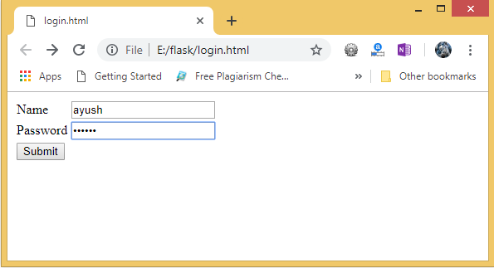
Give the required input and click Submit, we will get the following result.
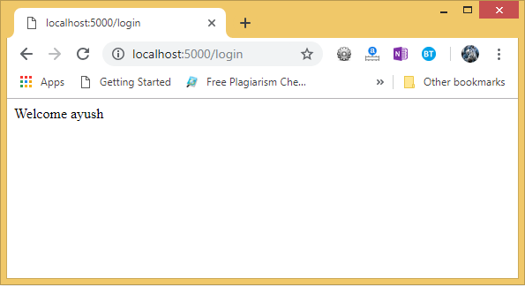
Hence, the form data is sent to the development server by using the post method.
GET Method
Let's consider the same example for the Get method. However, there are some changes in the data retrieval syntax on the server side. First, create a form as login.html.
login.html
- <html>
- <body>
- <form action = "http://localhost:5000/login" method = "get">
- <table>
- <tr><td>Name</td>
- <td><input type ="text" name ="uname"></td></tr>
- <tr><td>Password</td>
- <td><input type ="password" name ="pass"></td></tr>
- <tr><td><input type = "submit"></td></tr>
- </table>
- </form>
- </body>
- </html>
Now, create the following python script as get_example.py.
get_example.py
- from flask import *
- app = Flask(__name__)

- @app.route('/login',methods = ['GET'])
- def login():
- uname=request.args.get('uname')
- passwrd=request.args.get('pass')
- if uname=="ayush" and passwrd=="google":
- return "Welcome %s" %uname

- if __name__ == '__main__':
- app.run(debug = True)
Now, open the HTML file, login.html on the web browser and give the required input.
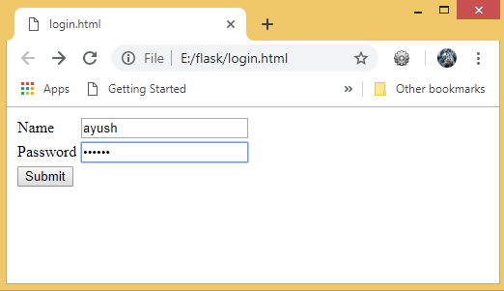
Now, click the submit button.
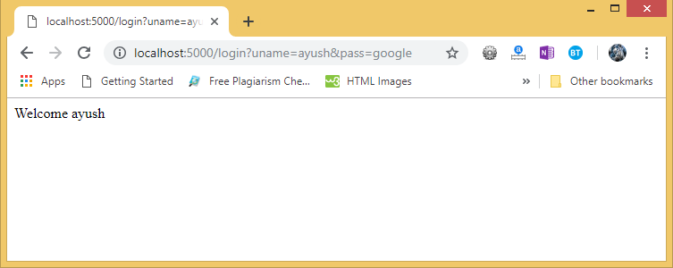
As we can check the result. The data sent using the get() method is retrieved on the development server.
The data is obtained by using the following line of code.
- uname = request.args.get('uname')
Here, the args is a dictionary object which contains the list of pairs of form parameter and its corresponding value.
In the above image, we can also check the URL which also contains the data sent with the request to the server. This is an important difference between the GET requests and the POST requests as the data sent to the server is not shown in the URL on the browser in the POST requests.

